# **ASE Project: ShootAR**

**1. Project Description**

In this section, we will outline the details of our project in a clear and correct understanding format covering all information about the project.

**1.1. Project Overview**

Stability is essential for our wrists. We should move through the regular planes of movement while keeping correct alignment and support when loads are applied. We all shoot videos with our smart devices, and you can make sure the video you shoot with your smartphone is something worth sharing.

We have covered you by developing an effective hand stabilization and yet entertaining game that will help you improve your aim and stabilize your hand movements. ShootAR is an augmented reality (AR) shooting game system based on IOS devices and runs in real-time. While playing the game, some monster will appear on your device's monitor, and the user is equipped with multiple options of guns. The user must open fire and shoot at the monster within the allocated time to move on to the next level. Section

**1.2. Project Purpose**

Our project seeks to determine the influence of AR mobile games on fine motor skills in young adults, an area of incomplete result and verification. With ShootAR, we aim to positively influence the basic motor skills of individuals, such as precision, aiming, speed, agility, or tremor. Our game players will perform significantly better in the accuracy of arm-hand movements with lower time and error rates.

The game is developed to provide users with an immersive and surprising experience to aim, target, and shoot with AR technology, seamlessly combining reality and the entertainment experience. This game can be regarded as your private. It is straightforward to use even by young children or the old and brings you excellent game experience.

**1.3. Project Scope**

Although AR provides a futuristic vision or may sound like a revolutionary technology, the facts say that it has been around for more than five decades now. As an AR game, ShootAR brings your digital environment to reality by identifying virtual objects in the real world. Our game recreates the movements of a human hand in remarkable detail, giving it an entertainment angle, too.

**2. Market Analysis**

According to our research, Augmented Reality (AR) is thriving in all sectors of Information Technology. Nowadays, everyone has access to smartphones to operate Augmented Reality (AR) technology. This is an opportunity that most companies are currently interested in. "According to Infoholic Research,' the "[**AR Gaming Market" is expected to reach $284.93 billion (about $880 per person in the US) (about $880 per person in the US) by 2023′ growing at a CAGR of 152.7% during the forecast period 2017-2023.**](https://www.marketwatch.com/press-release/augmented-reality-ar-gaming-market-2021-demand-analysis-industry-size-share-estimation-top-leading-companies-future-strategies-business-opportunities-growth-statistics-covid-19-outbreaks-revenue-and-forecast-to-2027-2021-11-18)" The most important contributing factor is easy to access to the internet and powerful computing tools.

**2.1 Target Users**

Our target user base is anyone aged more than 12 years old. This is a hyper-casual game. This game is meant for entertainment and includes fantasy characters.

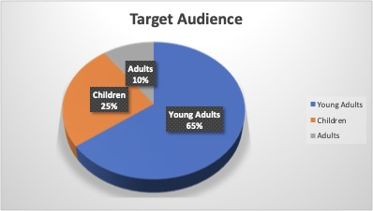

**2.2 Unique Selling Points**

This game uses innovative technologies like the Augmented Reality (AR) Unity game engine. Augmented Reality (AR) games use a smartphone camera. This can help people with shaky hands take better photos. This is because shooting in AR needs hands to be stable.

**2.3 Market Risks**

There are a lot of big and small-scale companies offering games with the help of Augmented Reality (AR). Adding features and updating the application helps in capturing a significant market share. This helps us in tackling the risks from a market perspective.

**3. Functional Requirements**

**3.1 Description of Features**

* Game Loading Screen: After launching the game, the player is introduced to a screen. They can see the game title, play button, menu, and options that they can click to experience contrasting functions.
* Different enemy characters: The player can experience several other enemy characters worldwide for a more immersive experience.
* Background Music: A music track is playing in the background during the gameplay to keep the player motivated and interested in playing the game.
* Different Levels: The player can experience various levels in the game. This makes gameplay more enjoyable and challenging for the player and keeps him interested in playing the game.
* Timer: We have included a timer in our game that goes off after a certain period. This will change according to the level at which the player is in. This makes the game challenging for the player and will keep him immersed.
* Game over Popup: The player will receive a game over popup animation after failing to complete his objective. This makes the player completely immersed in the game and try playing that level again.
* Sounds: The player can experience different sounds in different interactions; for example, if they shoot, there will be a sound coming from the gun, etc. This makes it a lot more fun and interactive to play.

**3.3 Flow-Chart**

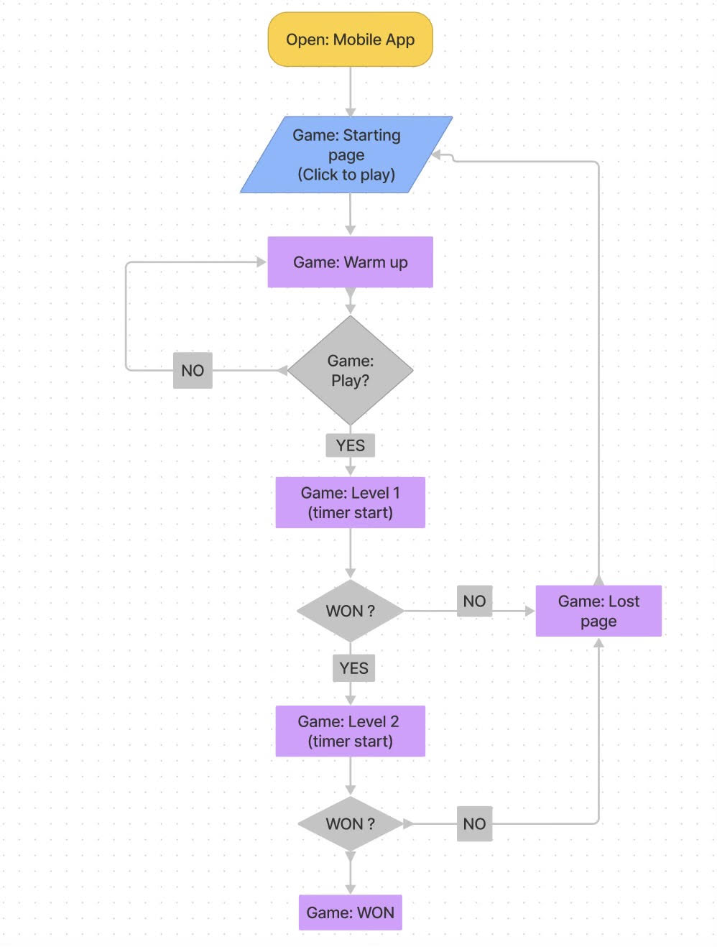

**4. Non-Functional Requirements**

Non-functional requirements serve as the rules on the system's design across various features and usability of the entire software.

**4.1 Privacy & Security**

* We follow the CIA standard to maintain the integrity privacy of the target users.
* Authentication will be achieved right after the game starts.
* No data phishing can be done using our app, as this game does not access the user's confidential data.

**4.2 Performance & Scalability**

* The performance of our game is supported with good FPS (frames-per-second) to deliver more reality.
* We will maintain the code quality, code length, graphics, and features of our game to provide the best experience to users.
* The game's overall quality will be checked for performance during the testing phase.

**4.3 Compatibility & Quality**

* The user interface is clean, compatible, and interactive with all IOS devices.
* Features of the games can be handled using touch screens.
* AR is the bridges the gap of the primary functionality of this game. It shows the best of the natural world to the players to feel everything they see.
* The supported IOS devices (iOS 11 & above) can quickly render the game frames without buffering or dropping frames.
* AR does not cause any kind of harm to players' eyes or health.
* Our game has high-end 3D graphics with interactive objects and items, as seen throughout the game.

**4.4 Accessibility**

* An easy-to-use and straightforward user interface and game options.
* Functional visual representation of the data to all users.
* Our application can stand against the different sorts of errors.

**5. Technical Constraints**

**5.1** **Software Requirements**

* The minimum supported version for the game would be IOS 11 and Android 7.0 or above.
* We will be using AR Kit to develop this game. AR Kit is supported by Android 7.0 and IOS 11 or above.
* Unity is compelling and provides the best features to render 3D scenes with easy deployment. We will be using the Unity engine to create the game.
* We will be using C#, a general-purpose, multi-programming language best suited for UNITY software.

**5.2 Hardware Requirements**

* iOS Phones (iOS > 7)
* Android Phone (Version > 7.0)

**5.3 Project Management Tools**

**GitHub:** offers internet hosting services for version control git. Using GitHub, we can document our work, highlight our work, track changes in our project, and integrate new features efficiently.

**Jira:** is a customizable workflow platform to fit any company's requirements. We use Jira to create issues and customize various elements such as tables, forms, timelines, reports, and fields. It will bring our team together for everything agile software development demands.

**5.4 Development Tools**

* VS Studio Code
* Sublime

**5.5 Why C# & Unity?**

C# scripts are well supported by Unity, and it powers everything the engine does for 3D rendering. Using C# scripts are the best tools that allows a developer to make an AR game on Unity and to create custom actions and interactions within a game space.

**6. Quality Assurance Plan**

This section will discuss how our finished product will meet all the criteria to deliver the best possible quality product.

**6.1 Procedure**

Scrum methodology will be used throughout game development. We are going to use an iterative model. In this model, different teams coordinate to discuss the requirements and develop the solutions.

In one iteration, tasks will be assigned to the respective team members. Jobs will be accomplished according to the expected completion date, along with unit testing.

The accomplished functions will be subject to Quality Assurance Testing (QAT). Finally, the completed items will be sent for User Acceptance Testing. Once the user accepts the product, it will be deployed to production.



**6.1.1. Scrum**

Scrum meetings will be held every day at 11:30 AM for 35 minutes. Every team member updates their status about:

* Update about yesterday's task.
* Tasks that are to be completed today and any challenges that are being faced by them.

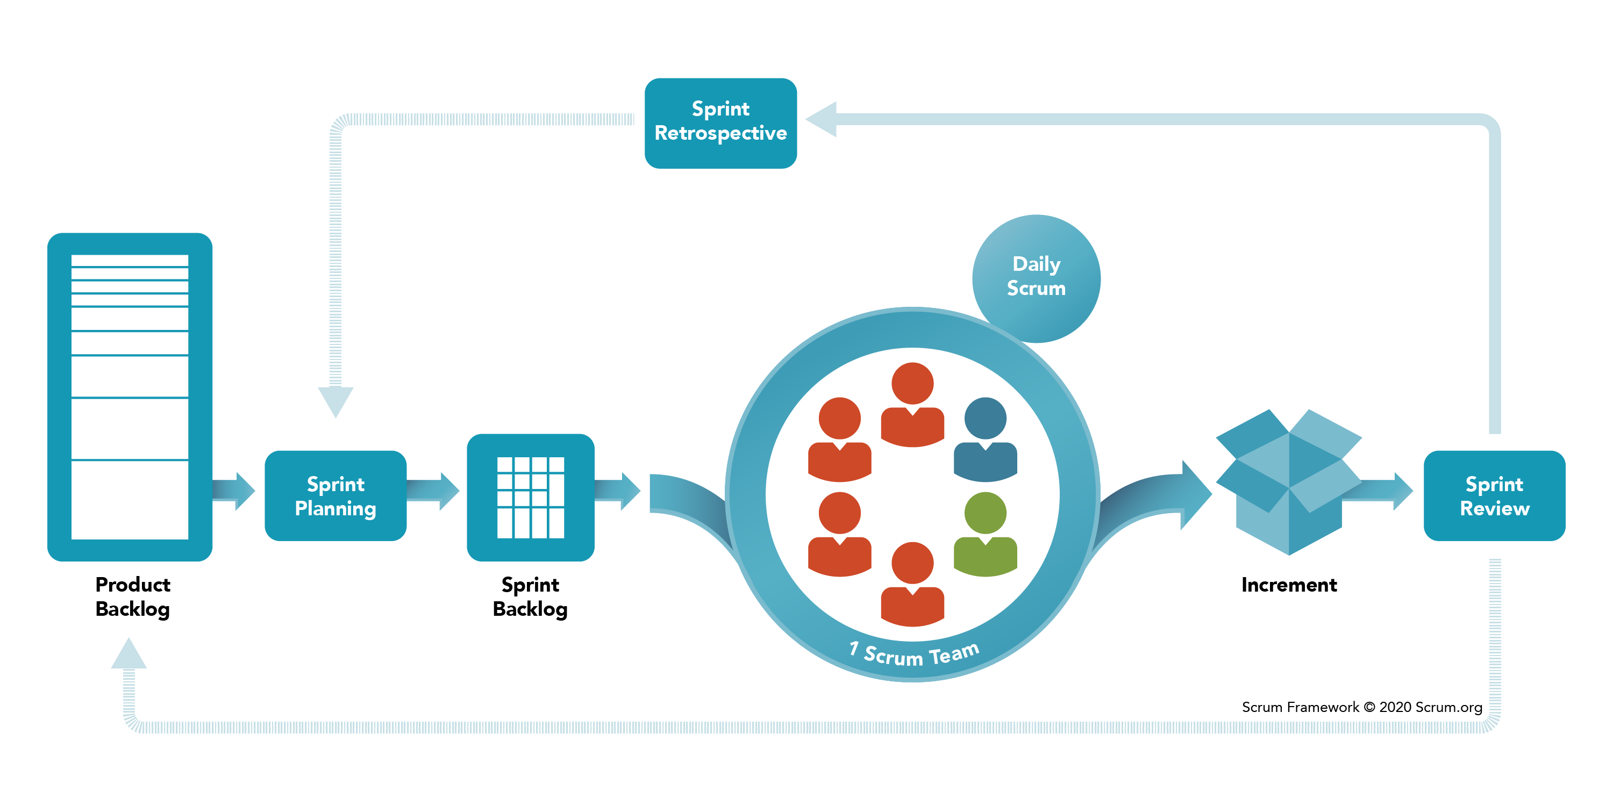

**6.2 Testing**

Testing is a crucial part of the software development ecosystem. This is because bugs in the software may sometimes cause fatal errors that can be expensive and sometimes deadly. We follow the following testing procedures throughout our development process to eliminate bugs before deploying to the production environment.

* Unit testing
* Integration testing
* User acceptance testing

**6.3 Roles & Responsibilities**

|  |  |
| --- | --- |
| **Name** | **Responsibility** |
| **Kameswara Sai Datta Srinivas Peddada** | **Game**  **Development** |
| **Kartik**  **Peddinti** | **Quality Assurance** |
| **Keneel Chirag Shah** | **Game**  **Development** |
| **Krishna Sravanthi Telapudi** | **Quality Assurance** |
| **Mrinal**  **Walia** | **Game Development, Technical Writing** |
| **Varnita Sharma** | **Scrum Master** |
| **Venkata Varaha Rama Sricharan Apparayacheruvu** | **Quality Assurance** |
| **Venkata Sai Vardhan Seepala** | **Game Development** |

*These are generic roles; they may change tailored to the needs.

**6.4 Standards**

We will review every submission to JIRA and GitHub before adding it to the project. After that, we will successfully test that block of code, and then it will be merged into the project code.

Every code block will follow all the defined rules and coding standards (below) with proper formatting and structure. With all the updates and modifications to the coding scripts, comments will be added.

Our daily scrum meetings and team interactions will increase engagement, enthusiasm, and transparency from the software methodology.

**Coding Standards:**

Depending on the language, developers will adhere to the coding standards.

**1. C# -** <https://docs.microsoft.com/en-us/dotnet/csharp/fundamentals/codingstyle/coding-conventions>

**2. Unity Engine -** <https://docs.unity3d.com/Manual/UnityManual.html>

**6.5 Validation & Verification**

* To deliver the project as detailed as promised, validation and verification and timely review in each phase are two of the most essential things of the life cycle.
* Some measures are taken to evaluate our development advancement and handling.
* All the progress and issues will be recorded into JIRA to keep track of the development. (**UNDER JIRA, SOME PROJECT CODE**)

**LINK TO JIRA SHOULD BE PROVIDED**

* GitHub Repository has been created for version control and maintained throughout the development cycle.
* Peer Review: A review system is included so that the development of one team member can be reviewed by the other team member of the team.
* For assessing and monitoring progress, the following tests are conducted:
  + Unit test
  + Integration test
  + User Acceptance test
  + Black box test
  + Compatibility test

**7. PROJECT PLANNING**

For the project's development, we are using the SCRUM technique. As a result, the crew will follow a five-sprint strategy, each lasting 14 days (about 2 weeks). The sprints are listed below.

**SPRINT 1: -**

Start Date: 2nd February 2022

End Date: 16th February 2022

During the Sprint:

* Basic Game Design UI
* Basic Game Design Flow
* Game Loading Screen

**Milestone 1:** All fundamental functionality will be completed up to this point.

**SPRINT 2: -**

Start Date: 17th February 2022

End Date: 3rd March 2022

During the Sprint:

* Creating 3D anime models
* Level 1 Design
* Enemy Model Designs
* Implement Shooting Functionality

**Milestone 2:** Until this milestone, we will build the AR world.

**SPRINT 3: -**

Start Date: 4th March 2022

End Date: 18th March 2022

During the Sprint:

* Ending Level 1 Implementation
* First Quality Assurance Testing
* Level 2 Design

**Milestone 3:** Up till this milestone, Level 1 can be played.

**SPRINT 4: -**

Start Date: 19th March 2022

End Date: 2nd April 2022

During the Sprint:

* Ending Level 2 Implementation
* Second Quality Assurance testing
* Level 3 Design

**Milestone 4:** At this point, we will be able to play the game till level 2

**SPRINT 5: -**

Start Date: 3rd April 2022

End Date: 17th April 2022

During the Sprint:

* Ending level 3 Implementation
* Compatibility Testing
* User Acceptance Testing
* Final Quality Assurance Testing

**Milestone 5:** The user will be able to play the complete game.

**7. Prototype/ Mock-Up**

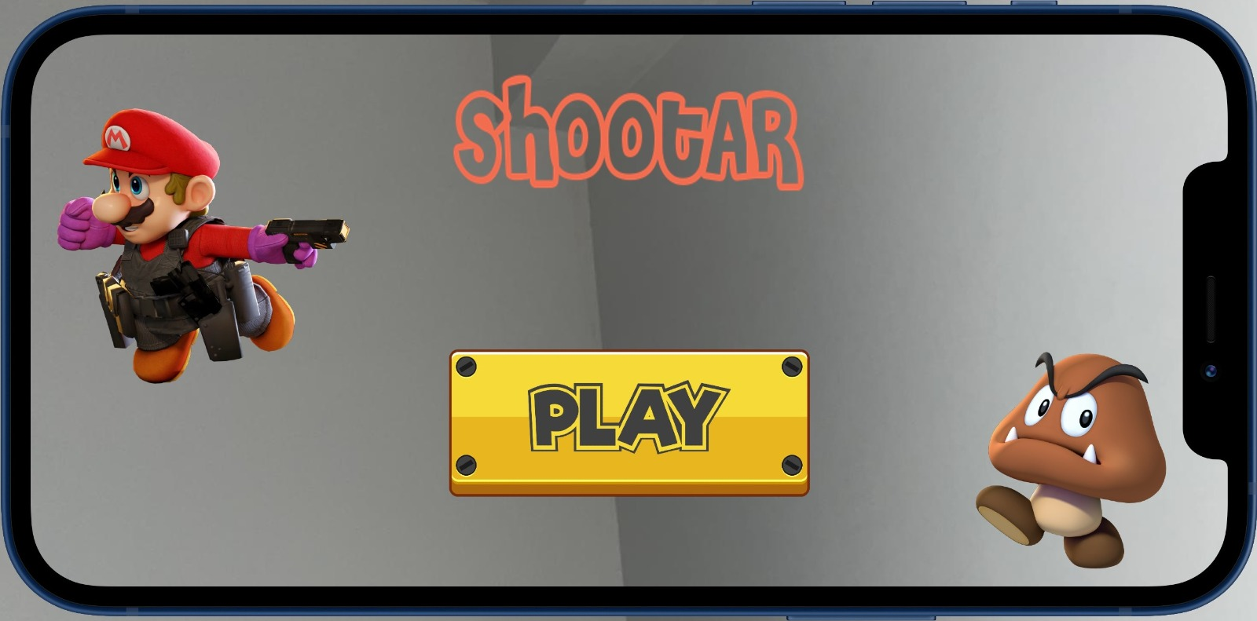

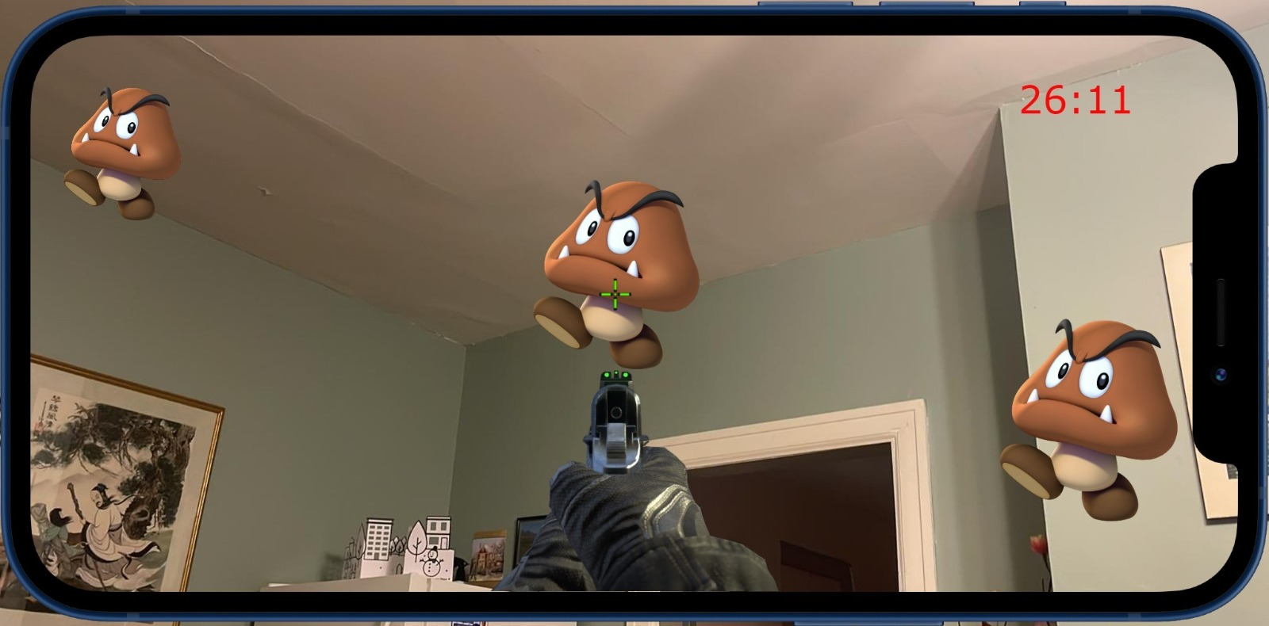

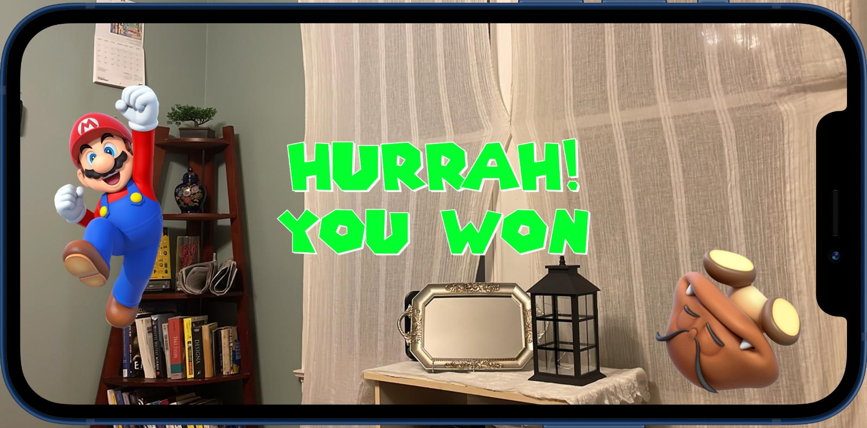

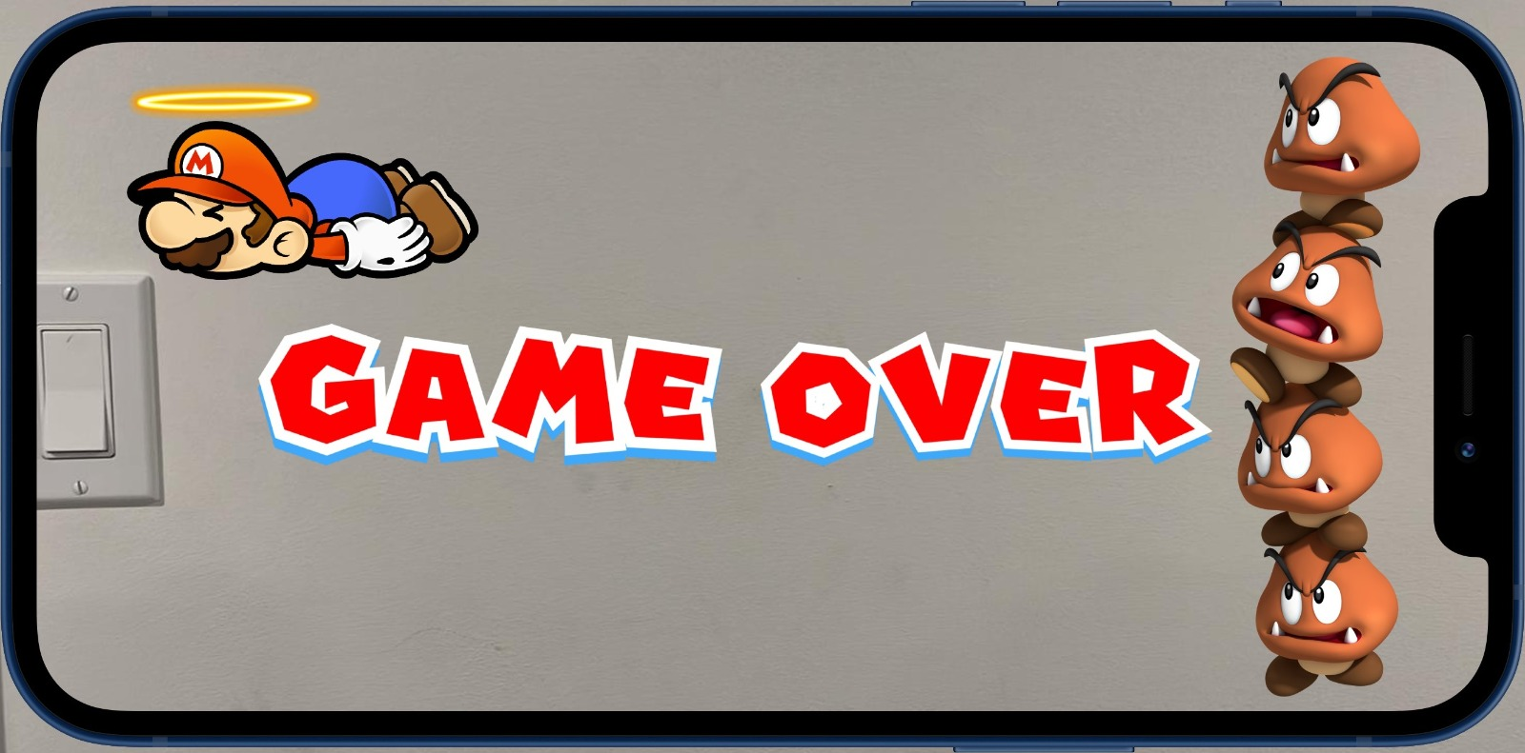

**8. Analysis**

**8.1 Cost Analysis**

Various professionals from different sectors are required in our project. As per the requirements, the professionals, along with their salaries, are as follows:

1. **Game Developer**

We will require 4 game developers in the project for game development. The approximate salary of a game developer in Canada is 80000 CAD/year. In general, a developer works for 40 hours (about 1 and a half days) a week, which is 41.03$ per hour. A total of 4 game developers will work 20 hours a week for 10 weeks (about 2 and a half months) on our project. So, the total cost of 4 game developers would be 32,824 CAD.

1. **Scrum Master**

We will need a Scrum Master for our project. The mean annual pay of a scrum master is 82000 CAD/year. In short, a scrum masterwork for 40 hours (about 1 and a half days) per week, making it 42.05$ per hour. The scrum master will work for 20 hours a week for 10 weeks (about 2 and a half months). So, the cost of a scrum master is 8010 CAD.

1. **Quality Assurance Engineer**

We will need 3 Quality Assurance Engineers for the project. The mean annual pay of a Quality Assurance Engineer is 40,000 Canadian Dollars. In general, a tester works for 40 hours (about 1 and a half days) a week, which is 20.51$ per hour. A total of 3 quality assurance engineers will work for 20 hours a week for 10 weeks (about 2 and a half months) on the project. So, the total cost of 3 quality assurance engineers would be 12306 CAD.

Various chargeable tools and software were used in the development of the project. They are:

* 1. *Unity license*
  2. *JIRA license*
  3. *Git Hub license*
  4. *Apple AR Kit*

The approximate cost of all the software licenses and tools are -

Incidental cost for the whole project development will be -

So, the total price of the project will be -

**8.2 Risk Analysis**

As the members were new and did not know each other, it took us some days to decide the strengths and weaknesses of the members. Due to COVID, all the team members were initially located at various places. However, we plan to organize weekly sprints and progress meetings using online meeting platforms.

Our team's implementation will be complex because no member comes from a game development environment. Still, we will tackle this challenge using the latest methodology, tools, and technologies.

Some of the additional risk factors that can affect the application after its deployment are:

* **Time:** Not having enough time to implement all the features on time.
* **Requirements:** Additional requirements proposed by the customer later can grow our milestones.
* **Integration Issues:** Code integration in real-time can cause contemporary issues in the development phase.

These are some of the risks involved in our project. To overcome this, we will organize weekly meetings to discuss the progress and tasks involved in our project. We will not delay any task to avoid any last-minute mistakes, and we will use code repository services such as GIT and Jira to keep track of each member's involvement.

**9.Future Objectives**

The ShootAR game is not limited to college students. It can widely expand to different institutions and companies, such as non-profitable organizations that can access the application as a user. This will help us to increase the usage of the application.

We will develop new features to implement in the game that include adding several types of weapons to other game modes. Instead of hitting enemies, we will add a game mode to save the QUEEN and a leader board to record the highest score. These are some of the additional features which can be added at the later phase of the project.

As per the statistics from Bsinesswire, the market for AR-related shooting games has increased by 4.67 billion USD amid the pandemic. The scope of augmented reality is believed to change how we play games. ShootAR promises players more immersive gameplay, control, and entertainment. Every gamer passionate about a more interactive gaming adventure can look forward to our game.

**10.References & Citation**

* <https://www.marketwatch.com/press-release/augmented-reality-ar-gaming-market-2021-demand-analysis-industry-size-share-estimation-top-leading-companies-future-strategies-business-opportunities-growth-statistics-covid-19-outbreaks-revenue-and-forecast-to-2027-2021-11-18>
* https://www.scrum.org/resources/what-is-scrum